SBR Coach FAQ
December, 2019

EVALUATIONS

Q. When are evaluations?

A. Usually the end of February and into March.

Q. Why so early?

A. For several reasons:
1. That is when the facilities are available.
2. We need time to hold call-backs for Premiere and Div. 1 teams.
3. We need time to conduct the drafts.
4. We need time to complete the rosters and submit them to CMSA.

Q. Am I allowed to attend evaluations as a coach?

A. Yes. We require coaches with softball knowledge to assist as subjective evaluators. You are free to take notes as well about players you would like to consider.

Q. I would like a specific skill evaluated. Can I request that?

A. We are open to suggestions but cannot guarantee your suggestion will be accepted as part of the evaluations.

TEAM SELECTION

Q. How are teams selected?

A. The Premiere and Division 1 teams are selected by the coaches as there is only one of each of those teams. The rest of the teams are selected via a draft.

Q. What information is provided to the coach for the draft?

A. All coaches will receive a summary of the evaluations of each player. They will also have access to all of the individual scores of every player available to be drafted.

Q. When is the information available?

A. We provide the information at the draft to control the access to the information and that it is not disseminated improperly. We are considering other alternatives and are open to suggestions. Please email Darren at pccoord@sbrsoftball.com with your thoughts.

Q. Can I be at evaluations?

A. Yes, we require coaches to assist at the evaluations to provide subjective evaluations. You are free to take notes as well about players you would like to consider.

SCHEDULE

Q. When does the season start and where is my schedule?

A. The season usually starts the last week of April but may change a bit each year. The schedule is set by CMSA, they are usually ready mid to late April and they will post them on their website.
CMSA Website address: (Link)
Go to Schedules/Standings,
Scroll to your age group,
Click the arrow beside Team Schedules,
Find your team name and click on it and it will take you to your team page.
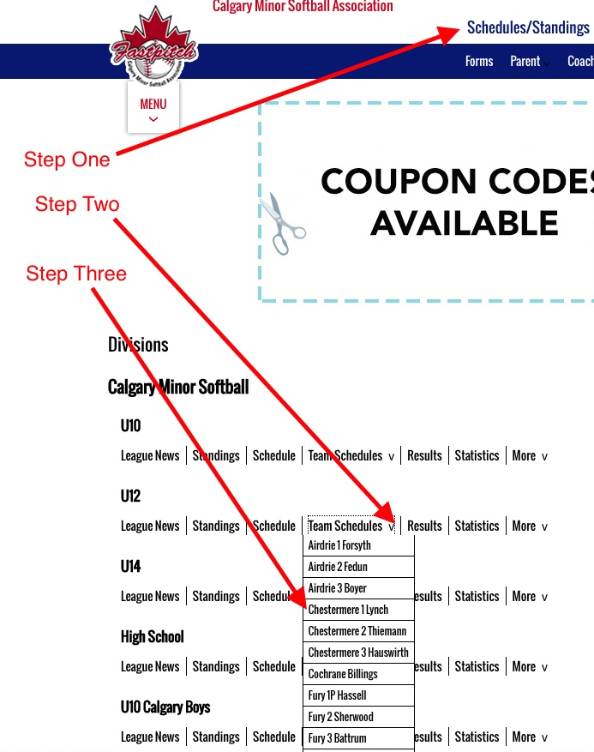

DIAMONDS

Q. Do I have an assigned diamond?

A. Yes. You will share a diamond with another team in an age group that is opposite nights as you play. For example, if you play Monday and Wednesday, you will share a diamond with a team that plays Tuesday and Thursday.

Q. Can I use my diamond at any time?

A. Not really. You can’t use it if your sharing team has a home game. However, if they have an away game you can use it. If you want to practice, check with your sharing team to make sure they are not using the diamond, then you can use it.

Q. Do I have a permit to be on the diamond?

A. During the week, yes. You will get an email with your diamond permit and you should print it out and keep it with you. On weekends diamonds are first come, first served but you should check with your sharing team to make sure they don’t have plans.

Q. Can I request a diamond?

A. Yes but there is no guarantee you will get your preferred diamond. Some are in high demand. The diamond coordinator will make best efforts to accommodate you or find the next closest diamond. Send your request to diamonds@sbrsoftball.com.

EQUIPMENT
Q. I have a question about equipment:

I don't have a piece of equipment I need, or I need another size of something, or I got a net with a hole in it, or my base broke, or I need different bats, etc.

- The answer is ALWAYS email Dave or Darren.
  - Dave: president@sbrsoftball.com
  - Darren: pccoord@sbrsoftbal.com

We go to great effort to make sure you have everything you need to have a successful season. If you are missing something or something is broken, we will get you what you need. We have lots of equipment and can get it to you quickly. However, we need to know about it. The earlier in the season you let us know the more time you can use the equipment. If we don’t have it and think we should we should, we will buy it.

Q. I heard there is a diamond drag and do I need a truck to pull it?

A. We did have diamond drags made up for every diamond this year. They are meant to be pulled by a person. One adult or a couple of players should be able to do it. We encourage you to drag your diamond before every game and practice to make sure there are not funny bounces. The key is in the equipment box.

Q. Where do I get a key to the equipment boxes?

A. They are handed out with the equipment, usually at the SBR coach orientation.

Q. I am already an awesome coach. Do I need to do all these orientations?

A. Yes. The CMSA Coach orientation needs to be taken once by every coach unless you have completed the Community Sport Ongoing training (This used to be called the NCCP Level 1).

If you don’t have the CSOG you HAVE to attend the CMSA coach orientation.

You MUST attend the SBR coach orientation as well. We discuss our expectations of you, appropriate conduct and numerous other topics. This is mandatory every year. You will receive your scorebook package and equipment as well. If you cannot attend, you must advise us and send someone in your place.

PLAYERS

Q. My player has a bunch of friends she absolutely MUST play with. How do I arrange this?

A. Above U10 there are no friend requests. All teams are selected by the coach (for Premiere and Div 1 teams) and by a draft for all other teams. Siblings will be selected together but otherwise, we will only grant friend requests in extreme circumstances as determined by the SBR Board.

Q. Do all players have to play every game?

A. Yes. As part of CMSA, we need to follow their rules. This includes universal substitution. That means all players bat and no player can sit a second inning until all players have sat an inning.

Q. I have a player that did not attend a pitching clinic. Is she allowed to pitch?

A. YES. All players that desire to try a position should be given proper coaching and the chance to try that position. If a player wants to pitch, you must coach them to the best of your abilities.

Q. I have some players that are not at the same level as the other girls on the team. Do I still have to play them?

A. Yes. All players must have equal and fair playing time throughout a season, including playoffs and provincials.

Q. I see in the rules I can sit a player for disciplinary reasons. Can I do that whenever I like?

A. The rules allow for this but SBR is very cautious about it being used and would be considered a last resort. You must discuss the situation with the parents and the player and explain why you are doing it. You must also have very good reasons why you are doing it as it is very likely to result in a parent complaint. It would be wise to send the Player/Coach Coordinator an email if you do plan to do this. pccoord@sbrsoftball.com. They are always available to discuss this, or other player concerns, as well.

SBR/BLUES TOURNAMENT

Q. Do I have to attend this tournament?

A. Yes. This tournament is part of your coaching obligations. It is a great opportunity for extra games and to introduce kids to what a tournament is all about. It is also a great chance to watch some higher-level ball with your team to show them older players playing the game.

Q. Do I have to register for the tournament?

A. No. It has been taken care of for you.

Q. Can I affiliate players for the tournament?

A. Probably not, as all SBR players are participating. If you have a situation where you may not have enough players please contact the Player/Coach Coordinator as soon as possible at pccoord@sbrsoftball.com or the Tournament Coordinator during the tournament.

Q. Do I as a coach have to volunteer at the tournament?

A. No. Your coaching counts as your volunteer commitment.

VOLUNTEERING

Q. Does coaching count towards my volunteer commitment? What about other roles?

A. The volunteering policy is at this link. One head coach two assistant coaches and one manager are allowed to count their volunteering towards their volunteer commitment. If you have a compelling reason another parent should have their bond covered you can send an email to SBR_Treasurer@shaw.ca who will consider your submission. However, it is rare to have these requests approved as the purpose of having mandatory volunteering is that we need volunteers to run all of the activities associated with running a league. If a parent occasionally acts as a scorekeeper or umps a couple of games, they will not get this approved as their volunteering. All parents are expected to assist the team to the best of their abilities. Parents do have the option of paying to not have to volunteer. This allows us to hire for the roles we do not have volunteers for.

RAIN OUTS/SCHEDULING MAKE UP GAMES

Q. Are games ever rained out?

A. Unless you are new to Calgary, you know that the weather in May and June is unpredictable, at best. It is almost certain games will be cancelled during the season. It can be for rain, snow, wind, extremely low temperatures, air quality or darkness. Be familiar with the CMSA weather policy located on the CMSA website here: (Link). CMSA also has an air quality policy which is here: (Link). The CMSA rulebook is here: (Link)

Q. Who can cancel games?

A. If the fields are not playable, or the temperatures are too low, then CMSA will cancel games by 4:00 pm. They rely on the Weather Network as the "official" weather resource: (www.theweathernetwork.com). If you have an umpire, they can decide that the conditions are not safe and cancel the games. You may not play after the umpire has left after cancelling a game.

Q. Who is responsible to re-schedule missed games?

A. The head coaches for the two teams need to communicate as soon as possible to find a date and a field that will work for both teams. SBR and CMSA do not re-schedule cancelled games, other than the opening weekend games.

Q. What is opening weekend and why does CMSA re-schedule those games?

A. At the start of each year, CMSA schedules a weekend of play so that all the teams can get four games in quickly. It is usually the last weekend of April or the first weekend of May. If CMSA can, they will re-schedule the weekend. However, if they do not, you must communicate with the other coach to re-schedule the game on your own.

OPENING WEEKEND
Q. What is opening weekend?

A. At the start of each year, CMSA schedules a weekend of play so that all the teams can get four games in quickly. It is usually the last weekend of April or the first weekend of May and games may be at different diamonds than what you normally play on.

UMPIRES

Q. Do all teams have an umpire supplied?

A. Some divisions have umpires supplied. Usually, it is U14 Div 1 and above.

Q. What do I do if I don’t have umpires supplied?

A. You can request umpires by sending an email to umpirerequest@calgaryminorsoftball.com. If they are able, they will schedule an umpire and you are responsible to pay them at the plate conference before the game.

Q. What if I can’t get an umpire?

A. If you are the home team, then you must get one of your parents to be the umpire. It is best to explain this to your parents at the start of the year. We suggest making a list and assigning the task to each family on a rotating basis. Then, if they cannot do it, they must find someone to do it. Parents, siblings, aunts, uncles, grandparents, friends are all acceptable to be the umpire. If no one else will do it, you are going behind the plate.

PROVINCIALS

Q. What do I need to know?

A. Lots of things!

- For most SBR teams the deadline is JUNE 1 to submit your application with the deadline to submit your roster being June 15.
- These are strict deadlines.
- Some of the information you require is on the Softball Alberta website under “Championships” and then “Provincials”. (Link to provincials page)
- The Provincials entry form is located under the “Forms” tab and then “Provincials”. (Link) The form asks you to justify why you selected the division you did. You need to explain why you selected a, b or c for example.
- The Provincial Roster form is on the same page. (Link)
- Select the age and division you intend to attend. The rules and draw will be there at the top of the page, as well as information about the weekend.
- A copy of the rules for U14B is here for your information. The rules don't change much from division to division but do be sure to read the specific rules to your age and division when they are provided.
- You need to make sure all of your players are attending. If not, you need to fill out a Calgary Minor Softball Provincial Non-Attendance Form (Link)
- If you are picking up players you need to fill out a CMSA Provincial Player Affiliation Form (Link) You also need to know the affiliate rules.
- The roster rules are different. Only 9 players can play at a time and the substitutions are more complicated. The rules are at 4-7 of the 2019-2020 Softball Canada Rulebook.
- Most provincials play on a Friday. Make sure your parents are aware!
- Coaches must attend coach meeting before the tournament. Often 8:00 am on a Friday. You need to be there.
- ALL bats are to be inspected at the coach meeting. If it does not have a sticker the bat can be tossed from the game.
- IF YOU HAVE ANY QUESTIONS ASK DAVE OR DARREN

CITY CHAMPIONSHIPS

Q. What are City Championships?

A. At the end of each season, CMSA hosts City Championships for each age division at u10 and above. Make sure your parents know that it can involve weekend play.

Q. Where can I find our schedule and rules?

A. They are on the CMSA website

Q. What are the rules for City Championships?

- Each division has rules for City Championships. The link for U10 is here: (Link)

Here is a picture of where to go as it can be a bit confusing:

